

web development

[Document subtitle]



February 13, 2023

mizA sheikh

[Company address]

|  |  |  |
| --- | --- | --- |
| **Year** | **Population** | **Growth Rate** |
| 2019 | 223,293,280 | 1.62% |
| 2020 | 227,196,741 | 1.75% |
| 2021 | 231,402,117 | 1.85% |
| 2022 | 235,824,862 | 1.91% |
| 2023 | 240,485,658 | 1.98% |

**ECONOMY : PAKISTAN’S STORY OF DEBUTE**

**The recent debate on whether Pakistan is going to default or not requires revisiting the country’s current debt and reviewing how it has accumulated over time.**

The story of Pakistan’s economy is incomplete without the character of its debt. Pakistan’s economic challenge began following Independence in August 1947, as it had to seek financial help. The structural diagnosis of Pakistan’s debt requires a deep understanding of policy interventions, which put the country on a debt trajectory, and an investigation of how certain groups pushed the country into debt to protect their vested interests.

The two South Asian economies — India and Pakistan — were in a dismal state at the time of Partition. Pakistan inherited 17 percent of colonial India’s revenue stream and about 33 percent of its army then. This inheritance set the budgetary priorities for the many governments to come.

Although we shared some economic experiences with neighbouring India, we could not come out of the debt trap since entering the first International Monetary Fund (IMF) programme in 1958. With a total of 22 IMF programmes, Pakistan has stayed under the multilateral lender’s shadow most of its independent life. In contrast, India and Bangladesh have reached out to the IMF only on seven and 10 occasions, respectively.

While Bangladesh’s economy no longer depends on external debt, studies show that it still happens to have a substantial negative relationship between economic growth and external debt. It must then be an even greater source of concern for Pakistan, which increasingly depends on external debt to meet its financing needs.

*The trajectory of Pakistan’s economy cannot be explained without delving into the debt it has accumulated over the last 75 years*

In the past 75 years, Pakistan has frequently faced multiple episodes of near-crisis experiences, where it had to face enormous pressures on fiscal imbalances and on its balance of payments. Time and again, the IMF has provided aid to prevent further damage, which Pakistan used to bring around short-term stability in the economy, using conventional economic stabilisation tools.

These crises are frequent, and their effects have accumulated in the long run. The long-term challenges have always been there and have been affecting the overall economic growth and development of the country.

India did lag behind Pakistan in the beginning. And at some point, in the 1980s, Pakistan’s economic growth exceeded India’s. But India’s 1990 economic reforms put it on the right path of sustainable growth. However, in Pakistan, boom and bust remained at the centre of its economic journey.

**WHAT HAS BROUGHT US HERE?**

After the first decade, Pakistan started spending more than it was earning. The size of the government continued to increase as government jobs were being exchanged with votes by political parties and with the support of military dictators, which mounted pressure on the national kitty.

The trajectory of Pakistan’s economy cannot be explained without delving into the debt the country had incurred over the last 75 years. The debt added to the combination of factors which translated into lower growth. This has resulted macroeconomic stability since Independence.

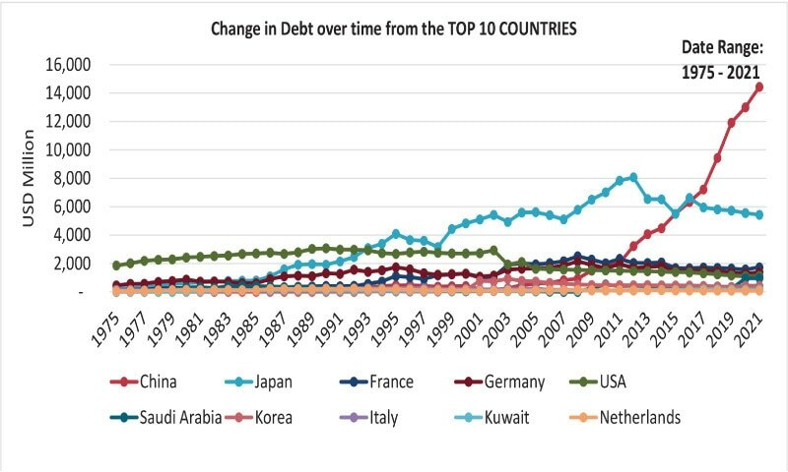 Pakistan’s current economic situation is evidence of the unrelenting issues in the structure of the economy. The country faces an unstable GDP, record-low exchange rate, accompanied with other issues, such as rising inflation and a widening current account deficit.

When it comes to the people, whose living is substantially affected by the instability and shocks, what serves as an aid in society’s ability in withstanding these economic shocks is the banking sector. At the same time, the successful reform of the banking sector is a necessary condition for fiscal and monetary stabilisation.

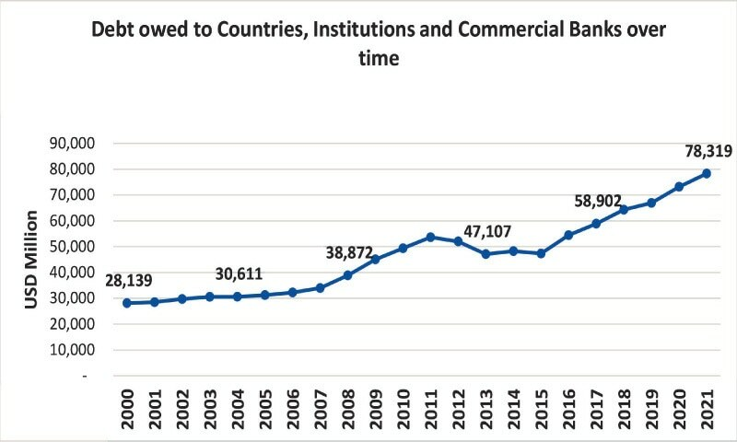 *In the past 75 years, Pakistan has frequently faced multiple episodes of near-crisis experiences, where it had to face enormous pressures on fiscal imbalances and on its balance of payments. Time and again, the IMF has provided aid to prevent further damage, which Pakistan used to bring around short-term stability in the economy, using conventional economic stabilisation tool*

But instead of fixing the economy at the structural level, the state has made it a rentier economy — extracting rent in an unproductive manner. Pakistan’s financial elite largely remains engaged in securing different subsidies, even if it makes the country borrow more and add to the existing debt.